­­



Submitted to

:

Mam Humaira Batool

***BS-Software Engineering 4th-E***

Title: LAB REPORTS

DBMS

Hamza Mehmood

Roll# SP-21-110

NUML-S21-23530



National University of Modern Languages

DBMS (MySQL)

# Chapter # 1

Introduction:

Database:

A database is simply a collection of structured data. A database is a place in

which data is stored and organized. The word “relational” means that the data

stored in the dataset is organized as tables. Every table relates in some ways. A

database is usually controlled by a database management system (DBMS). Data

within the most common types of databases in operation today is typically

modeled in rows and columns in a series of tables to make processing and data

querying efficient. The data can then be easily accessed, managed, modified,

updated, controlled, and organized. Most databases use structured query

language (SQL) for writing and querying data.

SQL:

* MySQL and SQL are not the same. Be aware that MySQL is one of the most
* popular RDBMS software’s brand names, which implements a client-server
* model. So, how do the client and server communicate in an RDBMS
* environment? They use a domain-specific language Structured Query Language
* (SQL). If you ever encounter other names that have SQL in them, like
* PostgreSQL and Microsoft SQL server, they are most likely brands which also
* use Structured Query Language syntax. RDBMS software is often written in
* other programming languages, but always uses SQL as their primary language
* to interact with the database. MySQL itself is written in C and C++.
* MySQL is a relational database management system (RDBMS) that is based on
* structured query language (SQL).

Features:

* MySQL server design is multi-layered with independent modules.
* MySQL is fully multithreaded by using kernel threads. It can handle
* multiple CPUs if they are available.
* MySQL provides transactional and non-transactional storage engines.
* MySQL has a high-speed thread-based memory allocation system.
* MySQL supports in-memory heap table.
* MySQL Handles large databases.
* MySQL Server works in client/server or embedded systems.
* MySQL Works on many different platforms.

Working:

MySQL follows the working of Client-Server Architecture. This model is

designed for the end-users called clients to access the resources from a central

computer known as a server using network services. Here, the clients make

requests through a graphical user interface (GUI), and the server will give the

desired output as soon as the instructions are matched. The process of MySQL

environment is the same as the client-server model.

The core of the MySQL database is the MySQL Server. This server is available as

a separate program and responsible for handling all the database instructions,

statements, or commands. The working of MySQL database with MySQL Server

are as follows:

1. MySQL creates a database that allows you to build many tables to store and

manipulate data and defining the relationship between each table.

2. Clients make requests through the GUI screen or command prompt by

using specific SQL expressions on MySQL.

3. Finally, the server application will respond with the requested expressions

and produce the desired result on the client-side.

A client can use any MySQL GUI. But, it is making sure that your GUI should be

lighter and user-friendly to make your data management activities faster and

easier. Some of the most widely used MySQL GUIs are MySQL Workbench,

SequelPro, DBVisualizer, and the Navicat DB Admin Tool. Some GUIs are

commercial, while some are free with limited functionality, and some are only

compatible with MacOS. Thus, you can choose the GUI according to your needs.

Installation:

MySQL is one of the most popular relational database management software that

is widely used in today's industry. It provides multi-user access support with

various storage engines. It is backed by Oracle Company. In this section, we are

going to learn how we can download and install MySQL for beginners.

Prerequisites

The following requirements should be available in your system to work with

MySQL:

MySQL Setup Software

Microsoft .NET Framework 4.5.2

Microsoft Visual C++ Redistributable for Visual Studio 2019

RAM 4 GB (6 GB recommended)

Download MySQL

1. Open the MySQL website on a browser. Click on the following link:

MySQL Downloads.

2. Select the Downloads option.

3. Select MySQL Installer for Windows.

4. Choose the desired installer and click on download.

5. After the download, open the installer.

6. It will ask for permission; when it does, click Yes. The installer will then

open. Now, it will ask to choose the setup type. Here, select Custom.

7. Click on Next. With this, you will install MySQL server, MySQL

Workbench, and MySQL shell.

8. Open MySQL Servers, select the server you want to install, and move it to

the Products/Features to be installed window section. Now, expand

Applications, choose MySQL Workbench and MySQL shell. Move both of

them to ‘Products/Features to be installed’.

9. Click on the Next button. Now, click on the Execute button to download

and install the MySQL server, MySQL Workbench, and the MySQL shell.

10.Once the product is ready to configure, click on Next. Under Type and

Networking, go with the default settings and select Next.

11.For authentication, use the recommended strong password encryption.

12.Set your MySQL Root password and click on next.

13.Go for the default windows service settings and under apply configuration,

click on execute. Once the configuration is complete, click on finish.

14.Complete the installation. This will now launch the MySQL Workbench

and the MySQL Shell.

15.Once MySQL Workbench is installed, select the Local instance and enter

the password.

Now, you can use the MySQL query tab to write your SQL queries.

### **SQL Statements:**

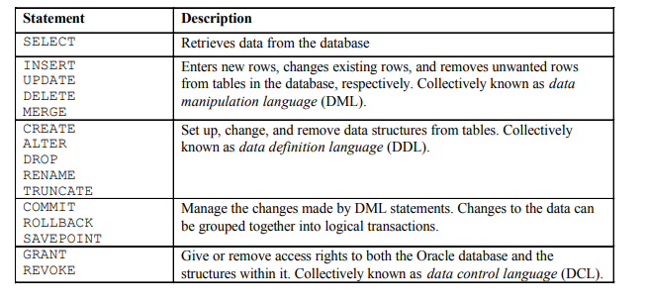

**SELECT Statement:**

Capabilities of SQL SELECT Statements a SELECT statement retrieves information from the database.

You can use the selection capability in SQL to choose the rows in a table that you want returned by a query.

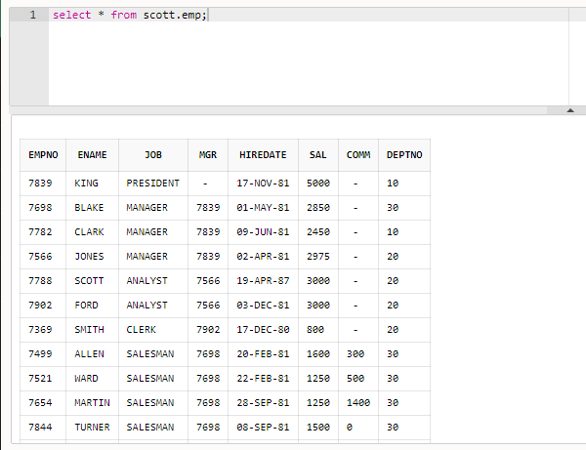

• SELECT identifies what columns.

• FROM identifies which table.

* * selects all tables.

**Selecting specific columns:**

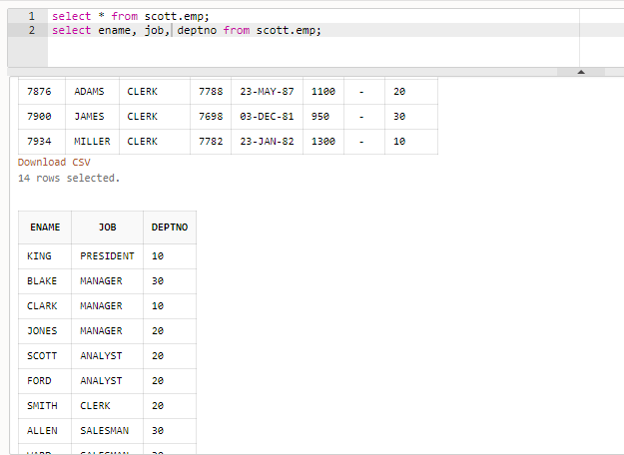

**Using Arithmetic Operators:**

We can create, edit or retrieve data from databases by using query. In this lab we use SQL (structured query language) to perform these tasks.

This key select all the columns/features of the table. We can specify the columns we want to use instead of *.

Select *

Select id

From table_name

Inside these two statements we write our functions we want to perform like multiplication, addition etc.

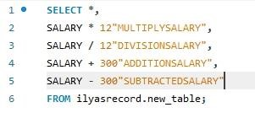

**Operator precedence:**

• Multiplication and division take priority over addition and subtraction.

• Operators of the same priority are evaluated from left to right.

• Parentheses are used to force prioritized evaluation and to clarify statements.

**Defining a Column Alias:**

A column alias:

• Renames a column heading.

• Is useful with calculations.

• Immediately follows the column name: there can also be the optional AS keyword between the column name and alias.

• Requires double quotation marks if it contains spaces or special characters or is case sensitive.

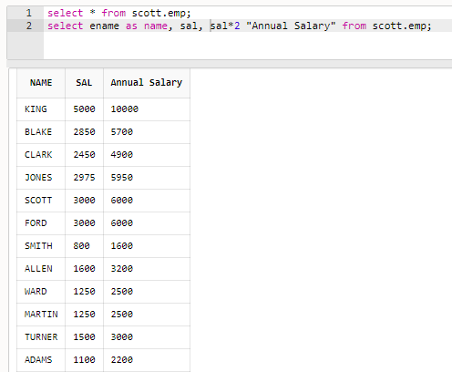

**Eliminating Duplicate Rows:**

Eliminate duplicate rows by using the DISTINCT keyword in the SELECT clause.

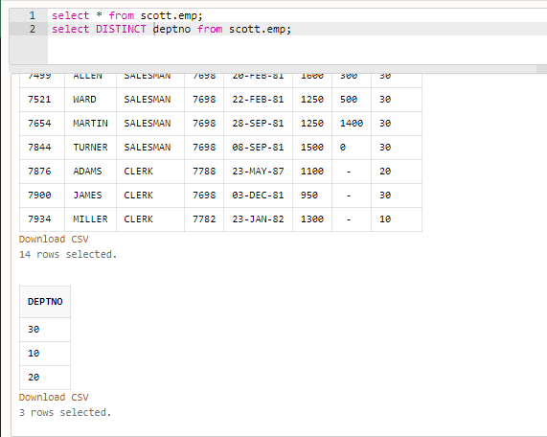

# Chapter # 2

**“Restricting and Sorting Data”**

Restricting using where clause and Sorting Data using order by clause and comparison operators:

Objectives:

* To limit the rows that are retrieved by a query
* To sort the rows that are retrieved by a query
* To use ampersand substitution to restrict and sort output at run time
* The selected table where we perform clause and operations on it

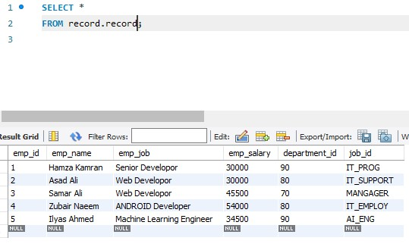

* Where clause in which we perform different comparison operators to perform a query

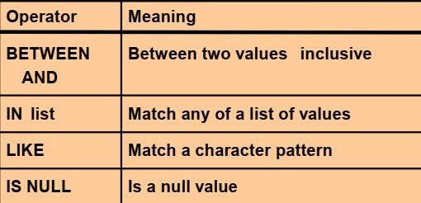

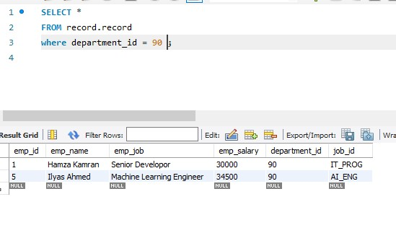

Greater than equals to operator:

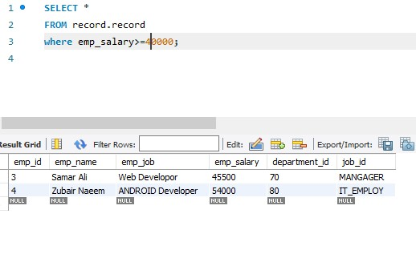

‘Between and operator :

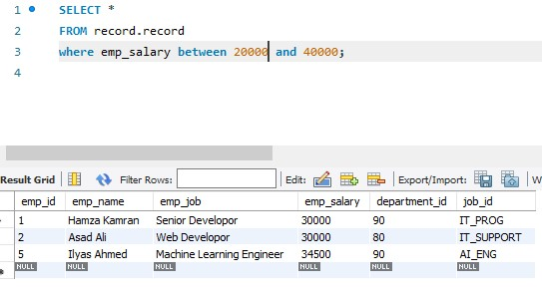

‘In’ operator:

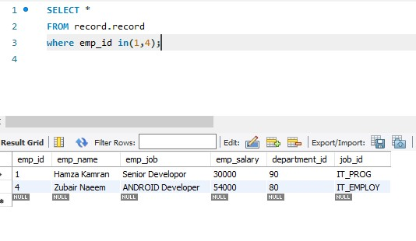

‘Like’ operator:

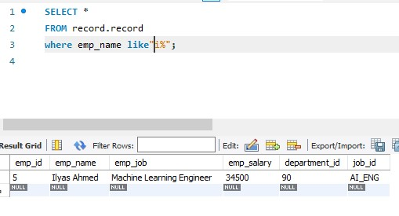

‘Like’ operator with two wildcards:

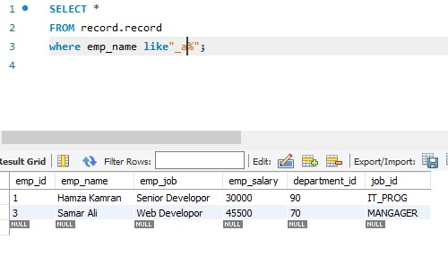

‘is null’ operator:

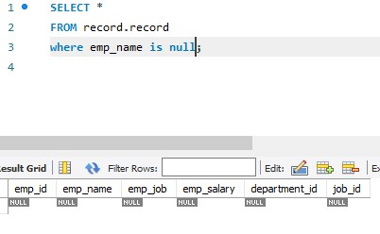

‘and’ operator:

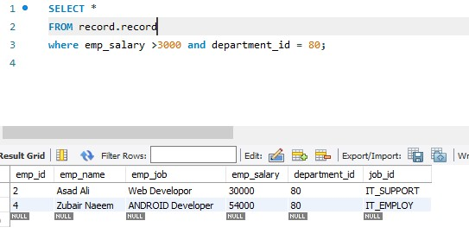

‘or’ operator:

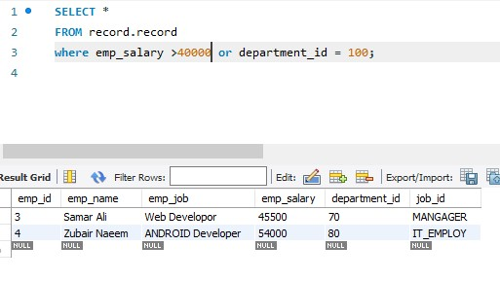

‘not in’ operator:

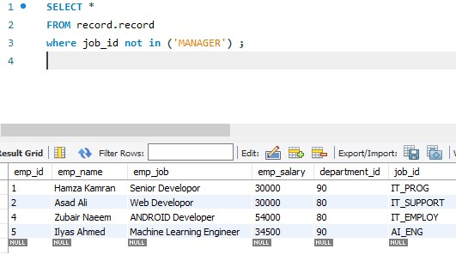

‘Order by’ operator is used for sorting by default order is ascending:

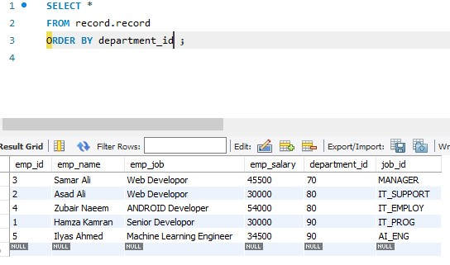

‘order by ’ operator in descending order:

